IT Operating Manual

<Service-ID> - ITOM - <short name IT-Service> - <SiteCode>

|  |  |
| --- | --- |
|  |  |
|  |  |
|  |  |
|  |  |
|  |  |
|  |  |
|  |  |
| **Main IT Service Catalogue Service** | <Service Catalogue ID : X.0.0 > |
| **Related IT Service Catalogue Service(s)** | <Service Catalogue ID : X.0.0 > |
|  | <Service Catalogue ID : X.0.0 > |
|  |  |
| **Prepared by** | < Author of this document> |
| **Date** | <dd.mm.yyyy> |
| **Version** | <V x.y> |
| **Status** | <Draft or Final> |
|  |  |
|  |  |

Content

Administration 3

1 Introduction 3

1.1 Create and Configure a new user 4

1.2 Create and configure new groups 5

Administration

**Version History**

|  |  |  |  |  |
| --- | --- | --- | --- | --- |
| Version | Date | Author | Change ID | Changes |
| <version> | <dd.mm.yyyy> | <author> | <USU change number stated as CID_xxxx > | <changes> |
| <version> | <dd.mm.yyyy> | <author> | <USU change number stated as CID_xxxx > | <changes> |

# Introduction

New user, group, and GPO creation

## Create and Configure a new user

Created the SIG-ADAudit account under the sig.dom/SIG Global Resources/Administrative Users OU

(Password in GITO PasswordSafe)

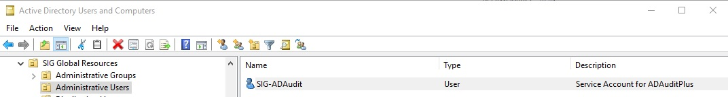

* Added user to the *Event Log Readers* group in the *sig.dom/Builtin* OU
* User granted the *Manage Auditing and security log* permission on the GPOs
* User made Admin on Servers and given *Read* permission on Shares
* User granted DCOM permission

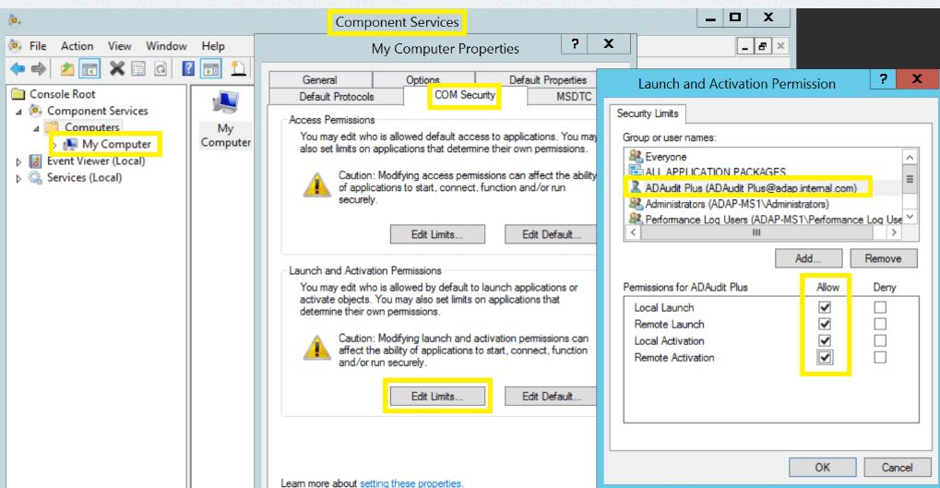

* User granted WMI permission:

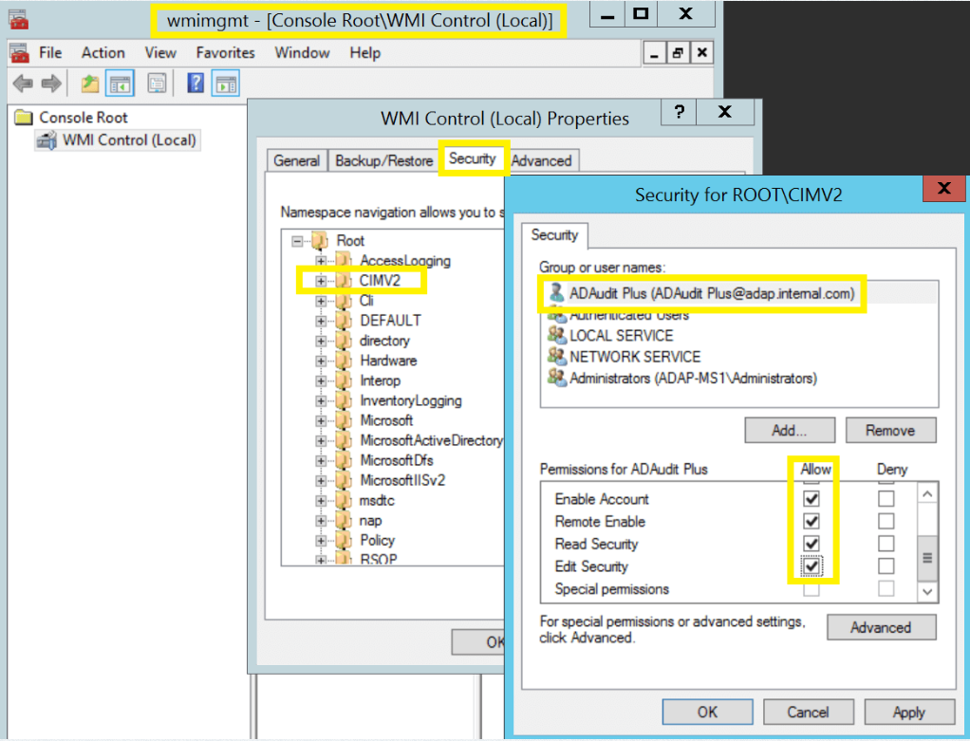

* User granted *Read* permission on *SYSVOL* folder
* User given *Full Control* over **ADAudit** installation folder on **DELINVMAS627**
* User given *Full Control* over *Archive* folder on **DELINVMAS627**
* User given *Full control* over all ADAudit Plus Scheduled Reports folders
* User given *Read and Execute* over all ADAudit Plus' Alert Script folders

## Create and configure new groups

Created the ***SR-SIG-ADAudit-FileServers*** and ***SR-SIG-ADAudit-MemberServers*** AD Groups



and set ***SIG-ADAudit*** as manager.

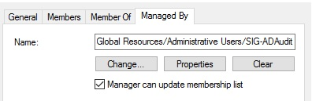

Added Managed Servers to Groups

Create a new domain level **GPO** and linked it to the audited computers

Created the 3 GPOs needed:



Set Delegation on GPOs as follows:

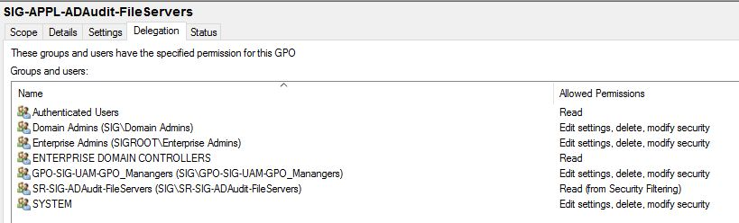

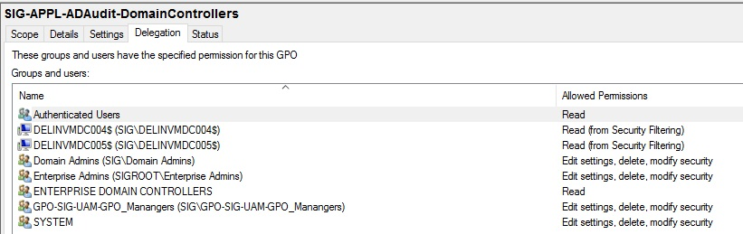

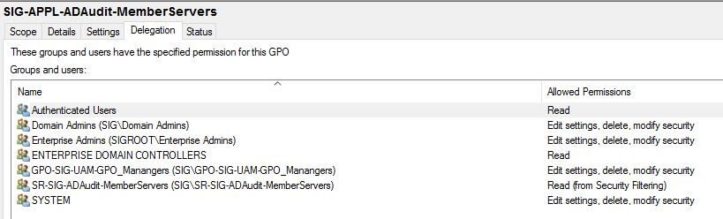

Linked the GPOs to the appropriate OUs and configured GPO Settings:

